Lab No. 3 Week 3

MPI PROGRAMMING

USE OF MPI_Beast, MPI Scatter and MPI_Gather

1) Write a MPI program to read N values in the root process. Root process sends one value to each process. Every process receives it prints the factorial of that number. Use N number of processes.

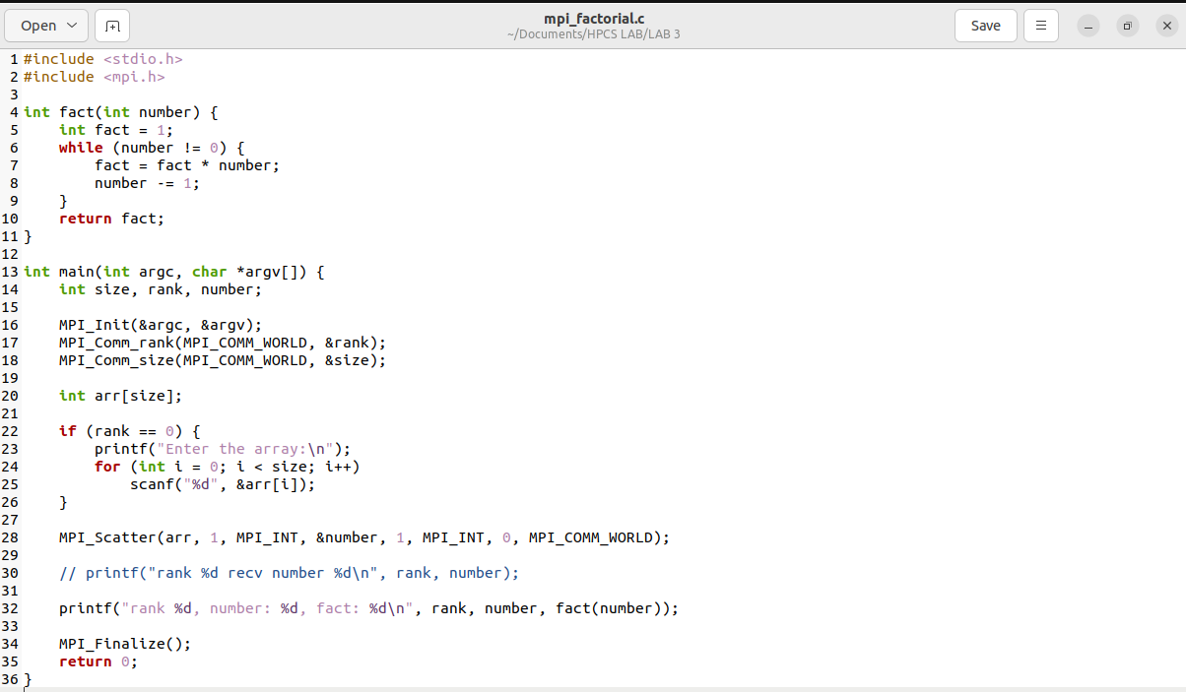

2) Write an MPI program to read a value M and N x M elements in the root process. The root process sends M elements to each process. Each process finds an average of M elements it receives and sends these average values to the root. Root collects all the values and finds the total average Use N number of processes.

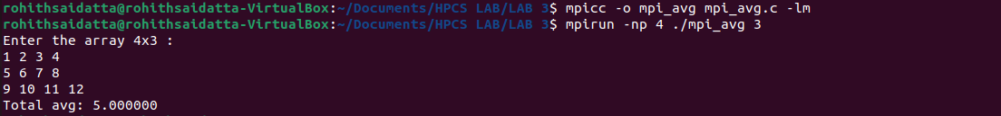

3) Write a MPI Program to read two strings S1 and S2 of same length in the root process. Using N process including the root (string length is evenly divisible by N), produce the concatenated resultant string as shown below. Display the resultant string in the root process.

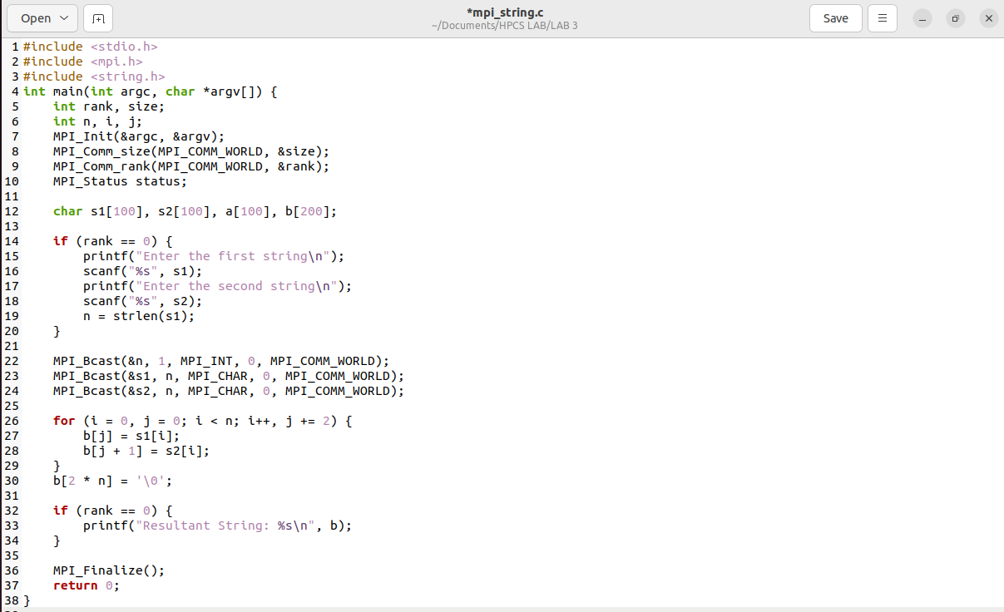

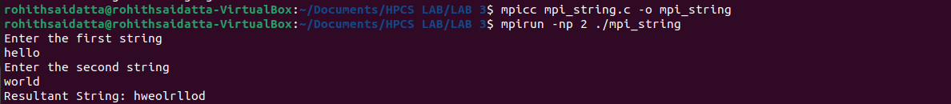

4) Write a program to read a value M and Nx M number of elements in the root. Using N processes do the following task. Find the square of first M numbers, Find the cube of next M numbers and so on. Print the results in the root.

